Kol simcha torah gazette
For parshas bamidbar 5784
Volume 8 Issue 37 (Whole #397) 2 Sivan 5784/ June 8, 2024
Printed L’illuy nishmas Nechama bas R’ Noach, a”h

For a free subscription, please forward your request to keren18@juno.com
Past emails can be found on the website ShabbosStories.com under Brooklyn Torah Gazette
Netanyahu, a Bereaved Mother and a Miraculous Pair of Tefillin
By Bruria Efune


Two weeks after donning Moshiko Davino's tefillin, Israeli Prime Minister Benjamin Netanyahu invited Ruchama Davino and Rabbi Or Ziv to thank them for the opportunity to wear this fallen soldier's miraculous tefillin.
Tuesday morning, in the midst of wartime meetings and urgent phone calls, Israeli Prime Minister Benjamin Netanyahu called Ruchama Davino and Chabad Rabbi Or Ziv to his office, to say thank you in person.
Two weeks earlier, on Israel’s day of remembrance for its fallen soldiers and victims of terror, Netanyahu donned tefillin in his office and prayed. An image snapped of the prime minister of Israel proudly wearing tefillin ricocheted around the world.
“The prime minister needed to give strength to the nation at a difficult time,” says Rabbi Ziv, who co-directs Chabad-Lubavitch of Katamon, in Jerusalem. “Wearing tefillin was the most moving way to do it.”
The tefillin themselves carry quite a story. They once belonged to Ruchama Davino’s son, Moshe, known by one and all as Moshiko, an Israeli soldier killed in Gaza in 2014.
That summer, during “Operation Protective Edge,” Moshiko was one of the first Israel Defense Force (IDF) soldiers to enter Gaza in a mission to find terror tunnels. He led troops in, clearing the road of mines with his D9 bulldozer. Tragically, a missile hit his cab, and he was killed at the young age of 20. When Rabbi Ziv learned that Ruchama was sitting shiva for her son in Katamon, he went to visit.
From there, a train of mitzvot in memory of Moshiko began.

‘Taking Care of Our Heroes’
“Ruchama wanted to do something good in her son’s memory, and to keep him alive, at her side,” says Rabbi Ziv. “We came up with the idea of the ‘Fun Truck.’”
The Fun Truck is a trailer built in memory of Moshiko, which Rabbi Ziv, Ruchama, and her family drive to distant army bases, bringing barbecues and joy to IDF soldiers. It continues Moshiko’s legacy as a young soldier who was always looking out for others, uplifting, and taking care of them. Since Oct. 7, the truck has been going out every single day, reaching soldiers on lonely outposts all along the Gaza border, and even up north under fire at the Lebanon border.
“It’s very satisfying to be able to give back to our soldiers, and to take care of our heroes,” Ruchama told Chabad.org. “We have so many volunteers and donors joining in. It’s wonderful.”
One day a few weeks after Oct. 7, after Israel had already launched its Iron Swords military response to the Palestinian declaration of war, Rabbi Ziv visited Ruchama and her family in their home. “I noticed that she has a small breakfront with a photo of Moshiko, and a few sentimental items that belonged to him,” he recalls. “Among them was a pair of tefillin.”

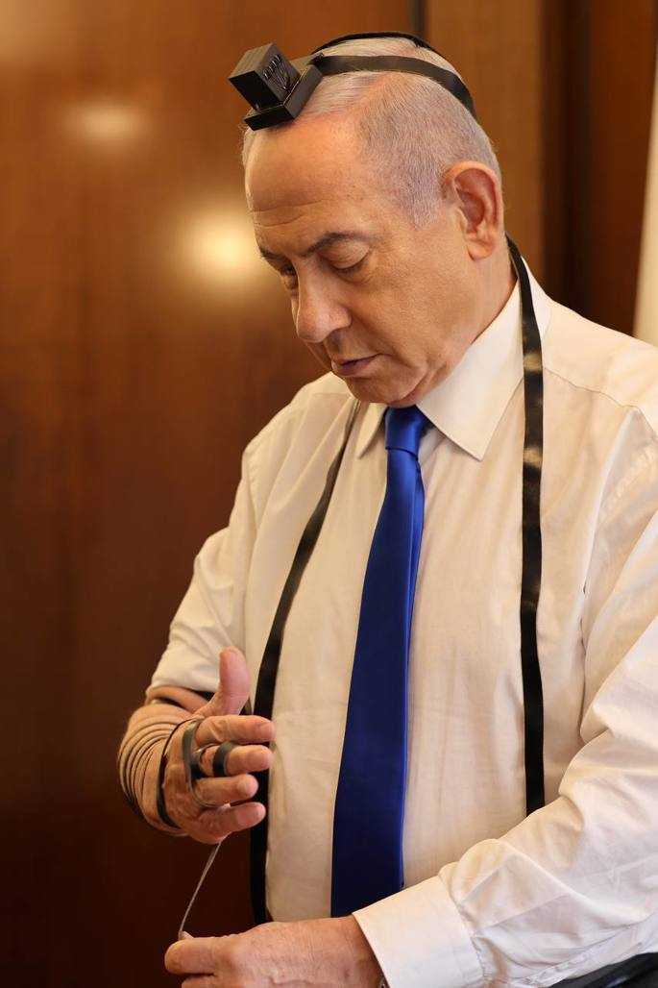
The photo of Netanyahu donning Moshiko’s tefillin and reciting the ancient words of the Shema prayer soon began circulating around the world.
Credit: Benjamin Netanyahu / Twitter
Ruchama told the rabbi the story of the tefillin. “All the soldiers knew Moshiko for his tefillin. Before every battle, he encouraged them to put them on as well, and say a prayer. He wanted every soldier in his company to be protected by the tefillin. It was important to him, and an inseparable piece of who he was.”
Moshiko put his tefillin to good use up until his last day. After Moshiko’s vehicle was hit, it caught on fire. The soldiers managed to retrieve Moshiko’s body but nothing else before it was completely engulfed in flames. Everything inside was burned to ashes, except for two items which were left in pristine condition: Moshiko’s tefillin and his Chitas, a compendium containing Chumash, Psalms, and Tanya (the foundational work of Chabad Chassidism), and a prayer book.
Rabbi Ziv was moved by the story. An idea popped into his head. “What do you think about having the Prime Minister don the tefillin?”
Ruchama reacted enthusiastically. She had always wanted to see Moshiko’s tefillin back in use, especially in a way he would have loved. After having the tefillin checked, and a few small repairs done, Ruchama wrote a letter to Netanyahu, and Rabbi Ziv sent it and the tefillin with a friend who had a forthcoming meeting with the prime minister.
Netanyahu had seldom—if ever—been seen publicly wearing tefillin. But soon they received an update: A promise to Ruchama that Netanyahu would don the tefillin, and send them a photo as well.

‘The Name of the Lord Upon You’
Months passed, and they heard nothing. It was understandable—the prime minister was busy with one crisis after the other. Soon things got really tense. Washington, D.C., was threatening a halt to vital weapons shipments and important military advancements were being delayed.
Finally, on the morning of Israel’s most painful memorial day in recent memory, Netanyahu donned Moshiko’s tefillin and recited the ancient words of the Shema prayer, “Hear, O Israel: G-d is our L-rd, G-d is one.” A photo of the moment was snapped and soon began spreading in Israel, and then around the world.
“His senior aides who were with him at the time tell me it was extremely emotional,” says Rabbi Ziv. “Some were moved to tears. The prime minister was visibly shaken. It was not an ordinary moment, not something they’d seen before.”
When Netanyahu himself publicly shared the photo, he did so accompanied by a verse from the book of Devarim: “Then all the peoples of the earth will see that the name of the Lord is called upon you, and they will fear you.”
It’s the same verse which the Rebbe—Rabbi Menachem M. Schneerson, of righteous memory—quoted in the runup to the 1967 Six-Day War, adding the Talmud’s explanation that this verse is a reference to tefillin. Every effort should be made, the Rebbe declared at the time, to assist Jewish soldiers protecting their brethren in the Holy Land in putting on tefillin, which would instill fear in the hearts of their enemies, and bring about certain victory.
Israel is a nation like no other, the Rebbe explained, “a people that will dwell alone” whose fate and ultimate victory lies in G-d’s hands. With their decisions impacting the lives of millions of Jews, this was something Israel’s political and military leaders needed to understand and appreciate even more than anyone else.
The Rebbe was thus particularly happy when, in the immediate aftermath of becoming an Israeli hero in 1967, then-Gen. Ariel Sharon proudly donned tefillin at the Western Wall. The photo of the event likewise made waves in Israel, being published in every major newspaper. In a letter to Sharon, the Rebbe noted “the tremendous inspiration that you aroused in the hearts of many of our Jewish brethren when you put on tefillin at the Western Wall, an act which merited great publicity and echoed powerfully and positively into the various strata of our nation ... ”

A Mother’s Consolation
Netanyahu was moved by the tefillin, and the fact that they were Moshiko’s. He wrote about thinking about Moshiko and the scent of the flames still lingering on the tefillin covers. He added, “I promised Ruchama that I would dedicate the tefillin for the elevation of Moshiko’s soul and for the elevation of all our fallen. That’s what I do today with holy reverence. May the memory of our fallen be blessed and kept in our hearts forever.”
“That our Prime Minister was wearing tefillin and holding a prayer book was very moving,” says Ruchama. “It was a message to the world: we have Hakadosh Baruch Hu, G-d, with us. The tefillin are our connection with Him, and because of Him, we will win.”
When the Prime Minister welcomed Ruchama Davino and Rabbi Ziv to his office this past Tuesday, it was to give a personal thank you to the mother who gave him strength and helped him inspire so many—with reactions far beyond what he had expected.
“In here,” he told Ruchama, pointing to Moshiko’s tefillin, “is a special power of our people.”
Netanyahu promised Ruchama that he will wear Moshiko’s tefillin on every Remembrance Day. Ruchama says she is filled with emotion, and more than anything, feels that her son is standing with her, bringing his light into the world. “It was his tefillin, again doing what he always did, up until his last day—connecting our nation to G-d Above, giving strength. I know he is filled with joy.”

Reprinted from the current website of Chabad.Org

The Jew’s Mission to Transform the Desolate Wasteland
From the Teachings of the Lubavitcher Rebbe
Rabbi Menachem Mendel Schneerson, Zt”l
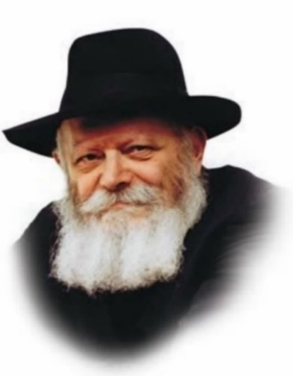

This Shabbat we begin reading from the Book of Numbers, whose Hebrew name, Bamidbar, means "in the desert." There are many places in the world that, from a Jewish perspective, are "deserts." Lacking even the most basic necessities of a Jewish community, the surrounding atmosphere is not one of Torah and sanctity. From a physical standpoint it might be a luxurious garden spot, but in the spiritual sense it is a "desolate wasteland."
A Jew finding himself in such a location might think that it is impossible to lead an authentic Jewish life under these conditions. He might even begin to compromise his Judaism, at first relinquishing those elements he doesn't consider "essential," yet gradually giving up things that really are. "Here it is different," he may say to himself. "A Jew cannot be expected to behave the same as if he lived in a traditional, Jewish neighborhood."
However, when we consider this week's Torah portion, the fallacy of such thinking becomes apparent. The Torah relates how the task of carrying the numerous components and vessels of the Sanctuary was divided among the Levite families. It describes how the journeys were conducted and how the Sanctuary was erected in every location the Jewish people encamped.
Indeed, it is quite astounding when we remember that all this occurred in a barren wilderness, devoid of human habitation. How was this possible in a place without life, let alone any trace of holiness or Judaism? And yet, the very first thing the Jews did upon arriving in an encampment was to erect the Sanctuary, immediately transforming it into a holy place where they could serve G-d!
The Torah thus teaches that G-d has not limited the power of holiness to operate only under certain specific conditions. Wherever a Jew goes, be it a "desolate wasteland" in the physical or spiritual sense, he has the ability to establish a "sanctuary" to G-d, to sanctify that place and spread the light of Torah and mitzvot.
All that is necessary is to allow the inner light of the G-dly soul to illuminate, to light up the correct path to follow. The Jew will then see how all obstacles and difficulties will disappear, until he too will reach the "Holy Land."
This concept, which applies to all Jews, is especially relevant to Jewish women. In the same way that the Jewish women were the first to contribute to the physical Sanctuary, so too do they play a unique role in erecting a spiritual sanctuary to G-d. As the "akeret habayit," the core and mainstay of the home, the Jewish woman has the unique ability to establish a Jewish tone in the home, and the strength to protect her family from negative influences.

Reprinted from the Parshas Bamidbar 5761/2001 edition of L’Chaim, a publication of the Lubavitch Youth Organization in Brooklyn. Adapted from Volume 2 of Likutei Sichot.
Thoughts that Count

And the L-rd spoke to Moses in the wilderness of Sinai, in the Tent of Meeting (Num. 1:1)
"In the wilderness of Sinai" teaches that a Jew should be as humble as Mount Sinai, the smallest of all the mountains; "in the Tent of Meeting" teaches that he should be joyous, as the word for "Meeting," "Moed," also means festival. The greater one's humility, the more genuine joy he will experience at having merited to be able to serve G-d. (Rabbi Elimelech of Lizhensk)

Take a census (literally "lift the head") of all the congregation of the people of Israel (Num. 1:1-2)
Moses' counting of the Jews caused the Divine Presence to rest among them. Every Jew realized that he was part of an exact, specific number, and that he, the individual, had the power to influence the fate of the entire nation. Similarly, Maimonides writes (in his Laws of Repentance): "Every person should consider himself...half innocent and half guilty, and the whole world as if half meritorious and half culpable. If he does one mitzva, he tips the balance to the side of merit and brings salvation and relief both to himself and entire world." Thus, by arousing them to repentance, the census caused G-d's Presence to dwell among the Jewish people.
(Shnei Luchot HaBrit)
Rav Avigdor Miller on
Freedom from Gentile Attitudes

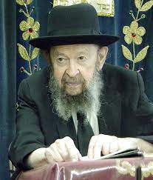

QUESTION: How do we free ourselves from the gentile attitudes that are all around us?
ANSWER: To free oneself from gentile slavery, number one is to learn what are true ideals. Because when you learn Torah ideals, you begin to look down on the gentile world.

A Victim of “Music Appreciation”
I’ll give you an example. Here’s a yeshiva man. He was four years in Mesivta high school. So, in the early part of the day, his rebbes tried to do a good job on him. But in the afternoons, the English teachers did a good job on him too. And they taught him among other things that there’s such a thing as ‘music appreciation’, to appreciate music. There’s a course in college called ‘music appreciation’.
Now if there was a course in playing the trombone, banging a drum, I understand that. It’s fun to bang it. It’s fun to blow. It’s fun even to bang a tom-tom. But do I have to go to take a course and to learn how much fun it is to bang a tom-tom?
Mimanafshach, if I enjoy it, so I’ll do it. If I don’t enjoy it, I don’t. Do I need a course to teach me how to eat Limburger cheese if I don’t like it? A course in appreciation of Limburger cheese?
It’s like caviar. Now, caviar doesn’t taste good. It’s only if you train yourself. If you have, let’s say, the attitude of being an upstart, you want to be a person who affects culture, so you force yourself at the beginning to eat caviar. The first few weeks you retch; it’s disgusting. But after a while you get a taste for caviar. It’s an expensive taste. Did it pay to acquire that taste?
And therefore, what’s music appreciation? It pays to acquire that taste?

The Poisoned Yeshiva Boy
But if you talk to this yeshiva boy now, he’s poisoned. He’s indoctrinated. He has a new ideal in life which to him is just as real as anything else.
Many people think that music is a true ideal. Music is nothing but irritation of the nerves; sound waves that irritate the nerves. So, if it irritates you pleasantly, good. But do you have to learn how it should irritate you? If it doesn’t, it doesn’t.
Now included in this are a great many of the affectations of the gentile world. And after a while, you begin to see through the gentiles. You see how false the ideals are. But if you’re innocent, you’re a babe in the woods, so you’re walking down Kings Highway and you see a picture, a big billboard picture, and you see a man smoking Winstons and you get the idea if you smoke Winstons you’re going to be wearing a ten-gallon hat and you’ll be sitting in the boat in the choppy sea or you’ll be in the windjammer holding a sail.
Or you’ll be lying on a beach with a female immodestly dressed next to you. Or you’ll be riding on a horse into the Maisa Mara (a game reserve in Kenya) as the sun is going down. All these things, if you’re innocent, you’ll get into your head associated with the cigarette.

Victims of the Billboards
And therefore, when you see a girl holding a cigarette like this, she’s imitating hundreds of pictures. She’s not thinking a cigarette is something good. She’s holding a cigarette like this because she’s thinking that at the same time she’s wearing a ten-gallon hat and she’s sitting on a horse riding into the Maisah Mara. Or she’s in a boat in the choppy sea holding a windjammer, whatever that is.
They’re plain victims of the billboards.
Here is a poor colored fellow walking down Fulton Avenue, Fulton Street. A colored fellow; he doesn’t know a thing. There’s nothing in his head at all. But he stops off at a candy store to get a mug of beer. While he’s holding a mug of beer, he thinks that he is identified with that famous jazz artist, a brown chocolate jazz player who’s on the billboard. That jazz fellow is holding a woman around with one hand and in his other hand is a jug of beer. He thinks that’s what he is when he’s drinking a beer.
So, if you live with gentile ideals and you read gentile books, you’ll think like a gentile. Why is it that fellows wear ragged pants? Because they think it’s romantic to wear ragged pants. They even buy pants with patches on it, readymade patches. America is so rich you can’t find patched pants. You have to buy specially made patched pants. And he thinks with patched pants he’s something noble.
Now if he’d get into his head that patched pants is ugly, that it’s associated with bad smells – because that’s what it is according to the emes. If he would learn Torah and get in the idea in his head that mankind is dignified, he couldn’t walk out half naked with a necklace on his chest. He’d be ashamed because he learned what the truth is.
But this half naked fellow, as he walks out, he thinks that he is somebody noble who has been described in plays. He sees in plays people like that.

Knocked His Father-in-Law on His Jaw
Or, I once had a yeshiva man, a frum yeshiva man, he married a girl from a not-religious family. So, he put a sheitel on her. Whenever he used to visit his in-laws they ridiculed his wife for wearing a sheitel. So, one day he took up and he struck his father-in-law in the jaw and knocked him down. He knocked his father-in-law down.
So, I spoke to him and I said, “Do you know why you knocked your father-in-law down? Because you’re an American. You read so many books. You’ve seen so many movies and so many comics in which the hero punches the other fellow in the jaw. He punches him in the jaw and that’s the last of the pictures. And there’s a big star, a flash around the jaw. S,o you got in your head that’s a noble thing to do. You’re not a ben Torah yet. If you were a ben Torah, you’d realize how disgusting that is.”

It is the Torah that Gives You Free Will
He didn’t understand me because he’s the victim of prejudices.
So, unless you learn Torah, you have all kinds of gentile prejudices in your head. And don’t think you have free will. Don’t think it’s the Torah that’s robbing you of your free will. The Torah is giving you free will. It’s opening your eyes to see how you, up till now, you’ve been walking in darkness. And now you see the light and now for the first time, you’ll become able to exercise your free will.
TAPE # 32 (May 1973)

Reprinted from a email of Toras Avigdor, based on the teachings of Rav Avigdor Miller, zt”l. Adapted from Tape #333 (October 9, 1980).

Rabbi Berel Wein on
Parshat Bamidbar 5784

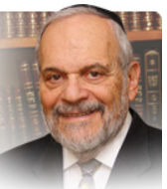

I have always been fascinated why this book of the Bible and this week’s Torah reading is called Bamidbar – in the desert. The rabbis of Midrash have stated that the lesson involved here is that the Torah only remains in a person who empties all other causes from one’s midst, and is as open and unoccupied as is the desert.

Nevertheless, there may be other insights that may be gleaned from the use of the desert as the backdrop for the events and laws contained in this fourth book of the Torah. One of these different insights has to do with the ability of water to transform a barren desert into a productive place of lush fields and orchards.

Here in Israel, the Negev desert that began fifty years ago just south of Chevron has now expanded many kilometers far south of Beersheba. This is due to the national water carrier system and other means of bringing water to that area of our country. Literally, the desert has bloomed in fulfillment of the ancient prophecies of Isaiah.

Water can overcome the arid dryness and barrenness of the desert of the Negev. In California, desert valleys have been transformed into America’s vegetable basket by systems of water diverted from the Colorado River. Again, in that case water was the key to transforming a desert into a garden and orchard. There are plans afloat all over the world to transform deserts into arable land. However, fresh water is a valuable and oftentimes scarce commodity and the struggle to discover and harness more of it for agricultural and human use is a continuous effort.

Throughout the books of the prophets of Israel and as well as within the Talmud, the Torah itself is metaphorically compared to and even called water. Just as water has the ability to convert desolate and nonproductive desert land into a veritable Garden of Eden, so too can Torah fill the void in our hearts and souls and make us productive holy people.

Torah, like the water that represents it, has this enormous regenerative power. The book of Bamidbar will, in its narrative of the many sad and tragic events that befall Israel in its sojourn in the desert, constantly reminds us of the powers of water/Torah to restore the Jewish people to a purposeful existence with greatly productive achievements in spite of all of its failures and backsliding.

No matter how bleak and barren the desert landscape in which we currently find ourselves, we should always be cognizant of the ability of Torah to refresh and renew us. The Jewish people are an old nation and yet our powers of rejuvenation have never waned. We were and are constantly nourished by the waters of Torah irrespective of whatever desert we found or find ourselves in. The choice of Jewish tradition to call this book of the Torah by the name of Bamidbar - in the desert – is meant to convey to us this message of hope, constant redemption, and rebirth.

Shabbat shalom

Reprinted from the current website of rabbiwein.com

Carrying the Tikun Home
By Rabbi Chaim Hillel Raskin


QUESTION: May I carry my Tikun Leil Shavuos home after I am done using it?
ANSWER: The Torah prohibits melacha on yom tov, yet permits melacha for the sake of food (ochel nefesh). On top of that, the principle of mitoch (“from the fact”) teaches that once a melacha is permitted for food purposes, that same melacha is also allowed for any other yom tov purpose.
Yet, this allowance is subject to several conditions, including: that the melacha will be enjoyed on yom tov, it is for the sake of yom tov or another passing mitzvah, it is a universal need (shaveh lechol nefesh), and it is for a yid.
Chazal heavily restricted the permitted melachos to ensure that one should actually enjoy yom tov and not be busy all day with melacha. They therefore ruled that any melacha that could be done before yom tov without compromising the taste or freshness of the food cannot be done on yom tov.
However, they did not place this restriction on carrying so as not to jeopardize simchas yom tov. Carrying a Tikun Leil Shavuos to shul is surely allowed since it will be used on yom tov.
But what about bringing it home after use? We find that Chazal permitted certain activities on yom tov after having finished his yom tov needs so that he will agree to begin the activity (hitiru sofan mishum techilasan – they permitted the end because of the beginning).
For example, they permitted putting out the hide of an animal slaughtered on yom tov for people to trample on it (which helps for the tanning) to encourage shechita on yom tov so that meat is available.
Thus, halacha states that one may bring home a machzor or tallis after use since if people couldn’t bring it home, and there is a risk of it getting lost or damaged in shul, they wouldn’t bring it to shul in the first place. However, if it was already in shul for a while before yom tov, that allowance isn’t applicable.
Some say that this allowance is only for mitzva related items, while other add that if he would wholeheartedly bring it to shul regardless, he should leave it there. If one has a safe place to keep it in shul or it is a garmet or talis that can be worn, some say he should do so and not rely on the heter. If the garment or talis was worn to shul, he must wear it home since there is no hitiru sofan mishum techilasan, and just as he wore it there he can wear it back.

Reprinted from the Parashat Bamidbar 5784 edition of The Weekly Farbrengen.

More Thoughts that Count

In most years, the Torah portion of Bamidbar is read on the Shabbat immediately before the holiday of Shavuot. This is because the main preparation for the Giving of the Torah is the mitzva of "And you shall love your fellow as yourself," Jewish unity, which Moses' census accomplished and underscored. (Beit Avraham)

Every man shall camp by his own flag, according to the sign of his father's house (Num. 2:2)
According to our Sages, every individual is obligated to ask himself, "When will my deeds reach the deeds of my forefathers?" This does not mean that a Jew has to worry about exactly emulating the Patriarchs, but that his behavior should at least "touch" (the Hebrew word for "reach" comes from the same root) the high standards ("sign") they set for him, and strive to follow in their ways. (Sefat Emet)

